Compulsory Assignment 3

Question 1. Counting.

*A standard deck of cards contains 52 cards: 13 cards each of 4 different “suits”, hearts (red), diamonds (red), spades (black), and clubs (black)*

1. *How many cards must be selected from a standard deck of cards to guarantee that at least 3 cards of the same suit are selected? Explain your answer.*

To figure out this question we can use the pigeonhole theorem, and when using the pigeonhole theorem, we always start by thinking of the worst-case scenario. For this question, it would be that we pick 2 cards of each sort, which would resort us to picking 8 cards. Then the next card we would pick regardless of the suit we would have picked 3 cards of the same suit. So, the answer to the question is 9.

1. *How many ways are there to select a pair of cards from a standard deck of cards such that one of the cards is red and the other one is black? Your answer can contain factorial or power expressions. Explain your answer.*

If the order of the cards doesn’t matter the first card can be anything of the 52 cards, then the next card we pic have to be one of the 26 others of the other colored suites. Then we got the answer of $52*26=1352$. Then again since order doesn’t matter, we need to dive our answer by $2!=2$, this is to remove the two cards but in a different order. So, the final answer to how many combinations of the red and black card we have is: $\frac{52*26}{2!}={26}^{2}=676$.

1. *How many ways are there to divide a standard deck of cards over 4 players? Your answer can contain factorial or power expressions. Explain your answer.*

To find how many possible combinations we can deal ¼ of the deck to one person we can use the combination formula $nCr =\frac{n!}{\left(n-r\right)!*r!}$. where our $n=52$ and $r=13$. $52C13=\frac{52!}{\left(52-13\right)!*13!}$ 
 . Now after we have given the first person, 13 cards / ¼ of the deck, we can give another 13 to the second player. The continuing like that until we reach the fourth player, we get an equation looking like this:

$$52C13*39C13*26C13*13C13 \\ = \frac{52!}{\left(52-13\right)!*13!}*\frac{39!}{\left(39-13\right)!*13!}*\frac{26!}{\left(26-13\right)!*13!}*\frac{13!}{\left(13-13\right)!*13!} \\ =\frac{52}{39!*13!}*\frac{39}{26!*13!}*\frac{26}{13!*13!}*\frac{13}{0!*13!} \\ =\frac{52!}{{\left(13!\right)}^{4}}$$

So, the number of ways you can divide a standard deck of cards across four people is: $\frac{52!}{{\left(13!\right)}^{4}}$.

**Question 2. Relations**

1. *Let $R$ be a binary relation on the set of integers such that $(a,b) ∈ R$ if and only if $b=2a$. What is the composite relation $R◦R$?*

$$R_{1}=R_{2}$$

Let $R_{1}$ be a relation from set A to set B, and let $R_{2}$ be a relation from set B to set C. The composition $R_{2}◦R_{1}$, consists of the ordered pairs $(a, c)$, such that $a∈A, b∈B,c∈C,\left(a,b\right)∈R_{1}, and \left(b, c\right)∈R_{2}$ 
 .

Now since $b=2a$, and the relations are both the same, the same rules imply for the second relation we have $c=2b$. So, to answer the question, the composite relation $R^{2}=\{\left(a,4a\right)\}$

1. *Let $R$ be a binary relation on the set of ordered pairs of integers such that $((a,b),(c,d)) ∈ R$ if and only if $ad=bc$. Show that $R$ is an equivalence relation.*

A relation R is an equivalence relation if the relation R is reflexive, transitive, and symmetric. So, we need to prove all of those to prove that it’s an equivalence relation.

First, we prove that the relation is reflexive:

Let $\left(a, b\right)∈A$  
Since $a*b=b*a$ $$(\left(a, b\right), \left(a, b\right))∈R$$

Thus, R is reflexive.

Now to prove it's transitive:

Let $\left(\left(a,b\right),\left(c,d\right)\right)∈R$ and $\left(\left(c,d\right),\left(e,f\right)\right)∈R$ $$ad=bc \\ cf=de$$ 
Since *a, b, c, d, e,* and *f* are all positive integers, they are all nonzero: $$a=\frac{bc}{d} \\ f=\frac{de}{c}$$ 
Multiply the previous two equations: $$af=\frac{bc}{d}*\frac{de}{c}=be$$ $af=be$
 then implies $$(\left(a,b\right),\left(e,f\right))∈R$$ 
Thus R is transitive.

And at the end we prove the relation is symmetric:

Let $\left(\left(a, b\right),\left(c, d\right)\right)∈R$ $$ad=bc$$ 
Then we use the commutative property of multiplication: $$da=cb$$ 
which is equivalent with $$cb=da$$ 
which implies $$\left(\left(c,d\right),\left(a,b\right)\right)∈R$$ 
Thus R is symmetric

In conclusion, since the relation is reflexive, transitive, and symmetric, it's an equivalence relation.

Question 3. Graphs

1. *For the undirected graph shown below, give the number of vertices, the number of edges, and the degree of each vertex, and represent the graph with an adjacency matrix.*

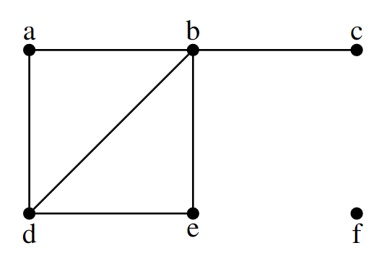

The graph has a total number of 6 vertices, and it also has 6 edges.  
Each vertex has this many degrees: $$\deg\left(a\right)=2 \\ \deg\left(b\right)=4 \\ \deg\left(c\right)=1 \\ \deg\left(d\right)=3 \\ \deg\left(e\right)=2 \\ \deg\left(f\right)=0$$ 
To represent the adjacency matrix:

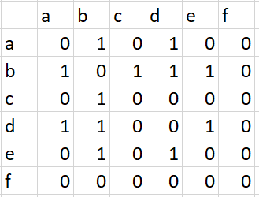

1. *For the undirected, weighted graph shown below, use Dijkstra’s algorithm to find the length of a shortest path from vertex $b$ to all other vertices.*

*Write down explicitly the steps of Dijkstra’s algorithm (the version in the lecture slides) by completing the tables below at each iteration of the algorithm (notation as in the lecture slides).*

*Here $S$ is the subset of vertices whose shortest path length from vertex $b$ has been deter-mined, and $N(S)$ is the neighborhood of $S$.*

*Here $L(v)$ is the current shortest path length from vertex $b$ to vertex $v$ and ‘–’ means the vertex has not been considered yet.*

